Lab - Guideline

Criteria to consider when choosing network media (from CISCO CCNA1).
What is the maximum distance that the media can successfully carry a signal?
Into what type of environment will the media be installed?
What is the amount of data and the speed at which it must be transmitted?
What is the cost of the media and installation?

A. Coaxial cables
- 10BASE2
- 10BASE5

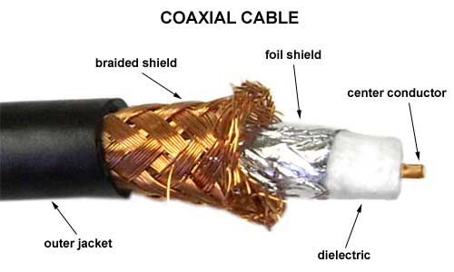

B. Twisted cables
- UTP
- FTP
- STP

Cat5e: 10/100/1000 Mbps over a max of 100m distance
Cat6: 1Gbps over a max of 100m distance and 10Gbps over 55m
Cat6a: 1/10Gbps over a max of 100m distance

RJ45 connector (part of 8P8C modular connectors), Cable Crimper Plier, punch down tool

EIA/TIA-T568-A and EIA/TIA-T568-B
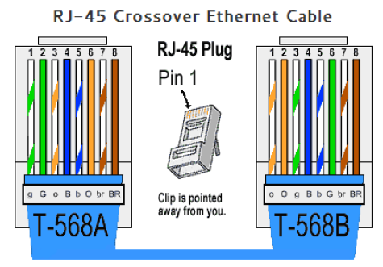
Patch cord, Patch panel, Hub = multiport repeater
Cable Tester
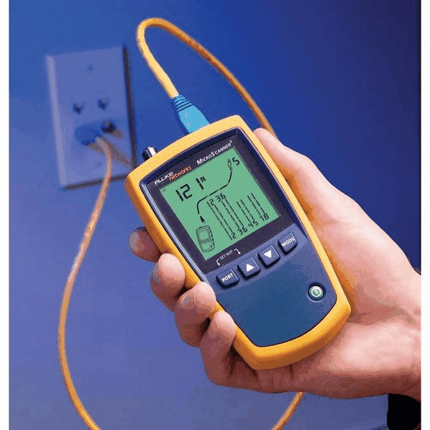

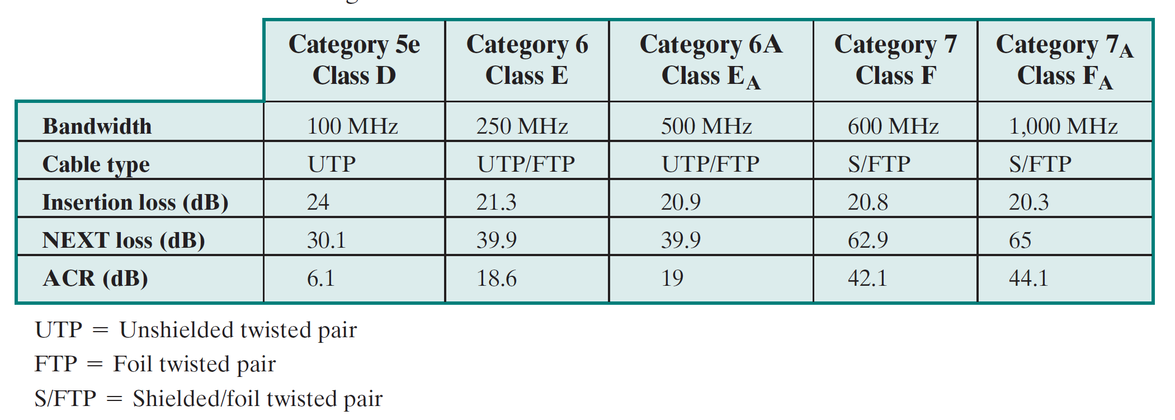

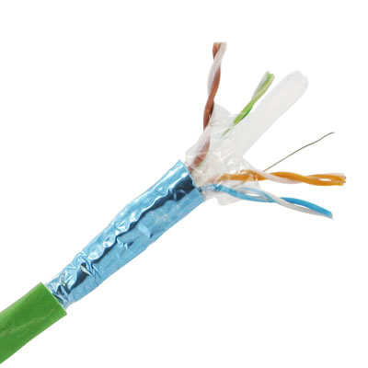cat6a

